Some MURS MU-5 radios were missing the Receive DCS tone on channel CCAREA which allows non-area traffic to be received. To allow area traffic only on channel CCAREA, set DCS D023N by following these instructions. Quick: [021, MENU, 9, MENU, ARROW UP, MENU, EXIT]

1. Press 021 on the keypad to select channel CCAREA. The display should have an arrow pointing to CCAREA like so:

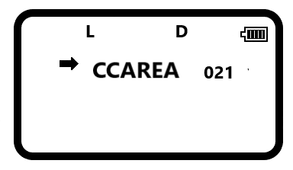

1. Press the Menu button (green button in the top left corner) of the keypad followed by 9. It should look like this:

1. Press Menu button again to change. Should look like this:

1. Finely, press the up arrow once to select D023N followed by Menu then Exit.

The yellow highlight shows the keys used for this setting. From left to right, Menu, Uparrow and Exit. On some radios, the exit button in the upper right may say Exit instead of the red arrow/cloud.

